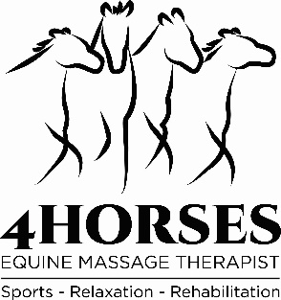
Michaela Winter Cert. ESMT / IAAMB reg.
07974 090301
4horses.esmt@gmail.com
VET CONSENT FORM
SECTION 1 - TO BE COMPLETED BY OWNER:
OWNERS DETAILS
Name
Address
Contact Number

HORSE DETAILS
Name
Colour / Sex
DOB or Age
Breed

SECTION 2 – TO BE COMPETED BY VET:
Veterinary Surgeon Name
Practice Address | PRACTICE STAMP
Practice Contact Number
Summary of Horse’s health
Previous injuries
Areas of caution to be noted
Current medication if any
Signature and Date:  (veterinary surgeon) | I hereby give full consent for the horse named above to receive massage treatments.
Veterinary consent is required by law for equine massage therapy in accordance with the Veterinary Permission Act (1966). IAAMB membership number: 2203. UK Rural Skills 2019:21149. Insured by Balens LTD.

